FOR IMMEDIATE RELEASE: January 18, 2021
Emily Pitcher
Sondering Studios
(805) 807-9506
spacebtwngame@gmail.com
The Space in Between, an unconventional visual novel featuring Asian American representation and mental health, releases for free
Story written from lived experience for those underrepresented in gaming
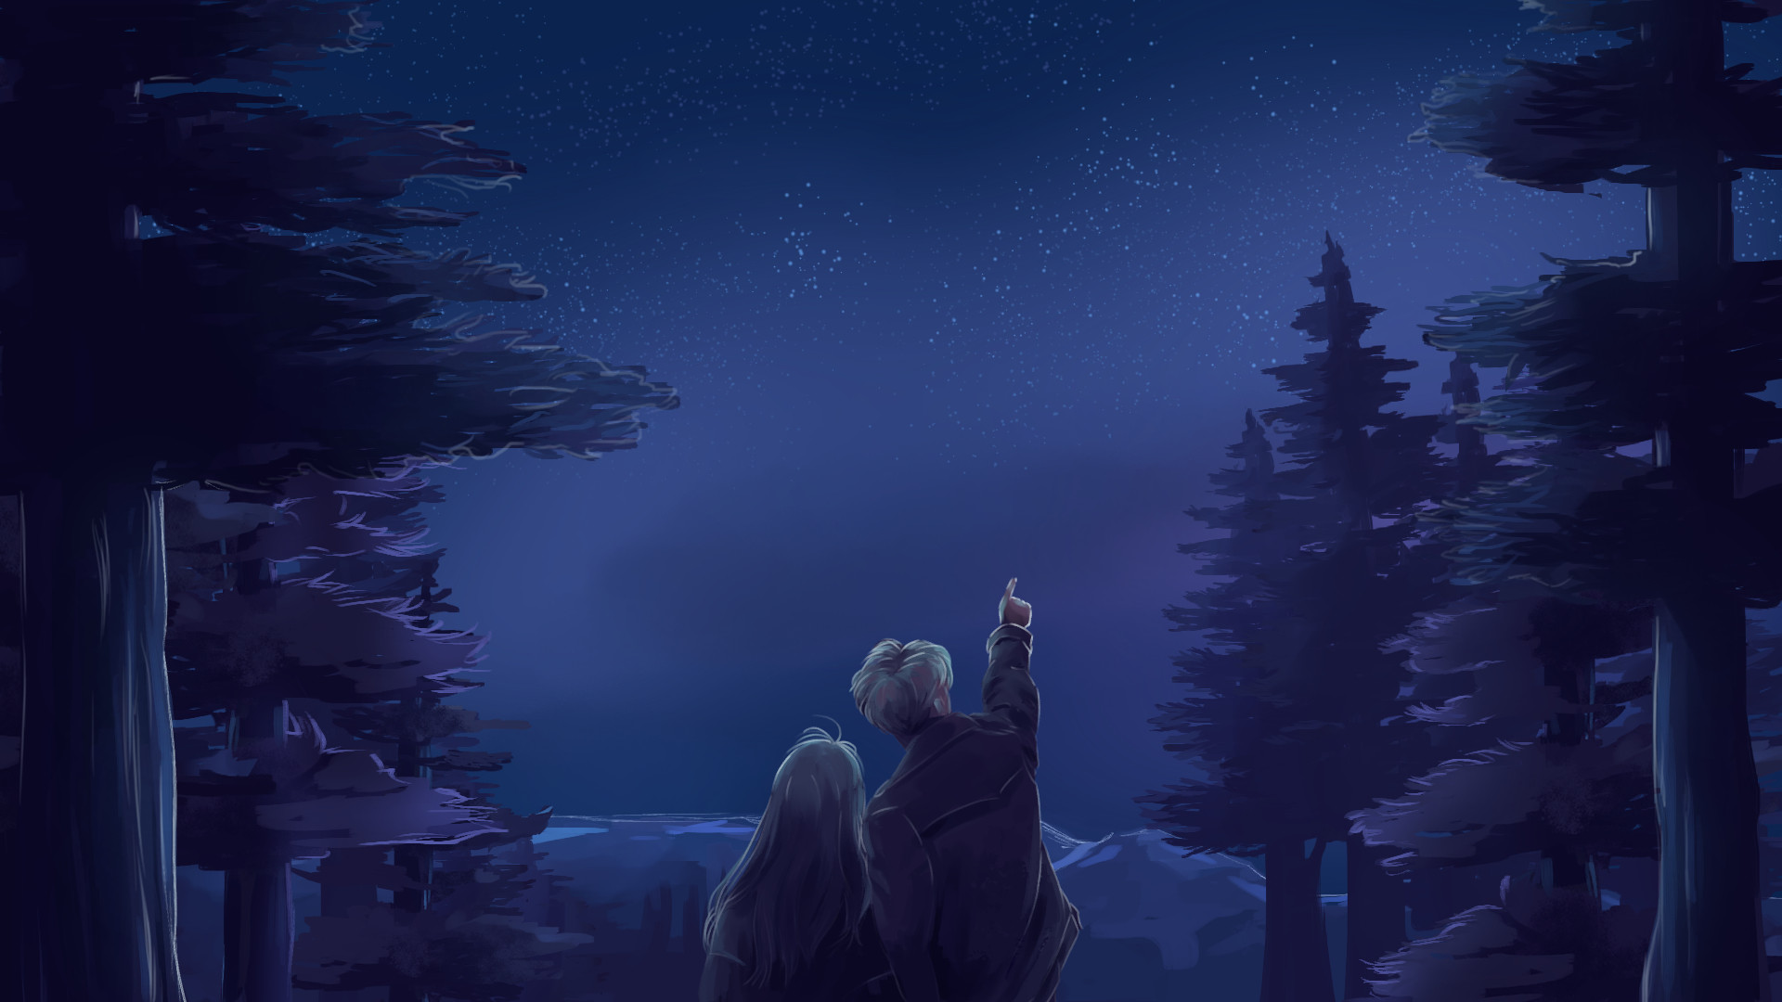
Los Angeles, California, United States of America -- January 18, 2021 -- Sondering Studios today released their first game, The Space in Between, for free on Steam (PC) and Itch (PC, Mac, Browser). Control the narrative of an emotional visual novel and dating simulator that features a poignant story about Asian American identity and mental health.
Indie studio Sondering Studios is headed by University of California, Los Angeles (UCLA) student Emily Pitcher, a Chinese American woman, and six of the seven other members working on The Space in Between are Asian American as well. Pitcher recognized that the few Asian roles in mainstream American gaming are samurai warriors or martial artists, so she wanted to create a project with contemporary representation. She hopes to make young creatives feel heard and pave the way for other women developers of color to tell their stories through gaming.
The Space in Between follows the love story between June, a spunky Chinese American college student trying to make sense of her complicated relationship with her immigrant mother, and Miles, a quiet artist who is recovering after a harsh past with mental illness. The player can affect the narrative by connecting stars to make constellations -- depending on what constellation the player forms, a different personal story is told. The game features two recommended playthroughs and original writing, art, and music.
Relive the first time you fell in love. Experience a nuanced perspective on the Chinese American experience and mental illness. Play The Space in Between for free on Steam and Itch.
Steam page (PC only): https://store.steampowered.com/app/1430240/The_Space_in_Between/
Itch page (PC, Mac, Browser): https://volcanogirl.itch.io/the-space-in-between
Press kit: https://alanguan98.github.io/The-Space-In-Between

